Ast 1013 - Intro to Astronomy Course Syllabus Fall 2022
Prof. Richard Anantua | richard.anantua@utsa.edu | www.richardanantua.com
Table of Contents
Astronomy 1013 Intoduction to Astronomy 2
Course Information 2
Learning Goals 2
Course Materials……………………………………………………………………………………...3
Activities and Grading ………………………………………………………………………………4
Essential Student Information……………………………………………………………………..5
Instructor Contact Information…………………………………………………………………….5
Communication Plan………………………………………………………………………………...6
Assessments and Assignments…………………………………………………………………...7
Course Schedule……………………………………………………………………………………..8
Course Management and Policies………………………………………………………………...9
Instructor-Initiated Drops…………………………………………………………………………...9
Student Code of Conduct and Scholastic Dishonesty………………………………………...9

Astro 1013 Intro to Astronomy
Fall 2022

Course Information
Course Description: A descriptive course including the development of astronomy, its methods, and the motions, laws, and evolution of the solar system. Topics include general properties and types of stars, unusual stellar objects such as quasars and black holes, galaxies, evolution, and cosmology. Occasional evening viewing sessions are held. May apply toward the Core Curriculum requirement in Life and Physical Sciences. Generally offered: Fall, Spring, Summer. Course Fees: LRC1 $12; LRS1 $46.20; MEPA $18; STSI $21.60; DL01 $75.
Nota bene: This is a Q-rated course satisfying UTSA’s Quantitative Scholarship requirement
Credit hours: [3]
Prerequisites/co-requisites: MAT 1023 or MAT 1073.
Course Modality: Traditional in-person (confer One Stop Enrollment) T and Th 1:00p-2:15p McKinney Humanities Building Room 2.01.06. Course registration number 10201

Learning Goals
At the end of the course, you will be able to: Identify and classify celestial bodies including planets, stars, nebulae, supernovae, jets, accretion disks, black holes, galaxies and galaxy clusters. Understand key physical concepts in astronomy such as temperature, force, energy and planetary motion. Correct common misconceptions such as seasons primarily arising due to Earth’s elliptical orbit or a flat Earth (without invoking curved spacetime).
The course goals, scaffolded by Bloom’s taxonomy, are to: Remember basic physical laws and our closest and best studied celestial bodies, e.g., stars, supermassive black holes, galaxies and galaxy clusters; Understand laws of thermodynamics, classical mechanics (particularly celestial dynamics); Apply our physical knowledge to unfamiliar systems to infer their motional and radiative properties; Analyze hypotheses based on astronomy news ,such as reports on the possibility we have been visited by extraterrestrial life; Evaluate space policy, such as whether NASA should have continued funding the Light Interferometer Space Antenna; and Create hypotheses on the fate of our civilization, planet and Universe.

Course Materials

Required Textbook + Software
Cosmic Perspectives by Jeffrey Bennett. Use the Cosmic Perspectives textbook with Mastering Astronomy for online assignments. A Cosmic Perspectives option that can be rented cheaply from Amazon is (ISBN-13: 978-0-13-487436-4; ISBN-10: 0-13-487436-6). Generally, Cosmic Perspectives and Mastering Astronomy can be bundled in three common ways you are free to choose from:
1.) (9th Edition Bound Cosmic Perspective + Mastering Astronomy Access Code)
ISBN-13: 9780135720875

2.) (9th Edition Looseleaf Cosmic Perspective + Mastering Astronomy Access Code)
ISBN-13: 9780135720943

3a.) 9th Edition Bound Cosmic Perspective ISBN-13: 9780134874364
3b.) Mastering Astronomy Access Code ISBN-13: 9780135208113

To access this course online and pair Mastering Astronomy online assignment system with Blackboard online grading interface:
-Login to Blackboard
-Go to Coursework -> Tools
-Select the Pearson’s MyLab & Mastering Icon
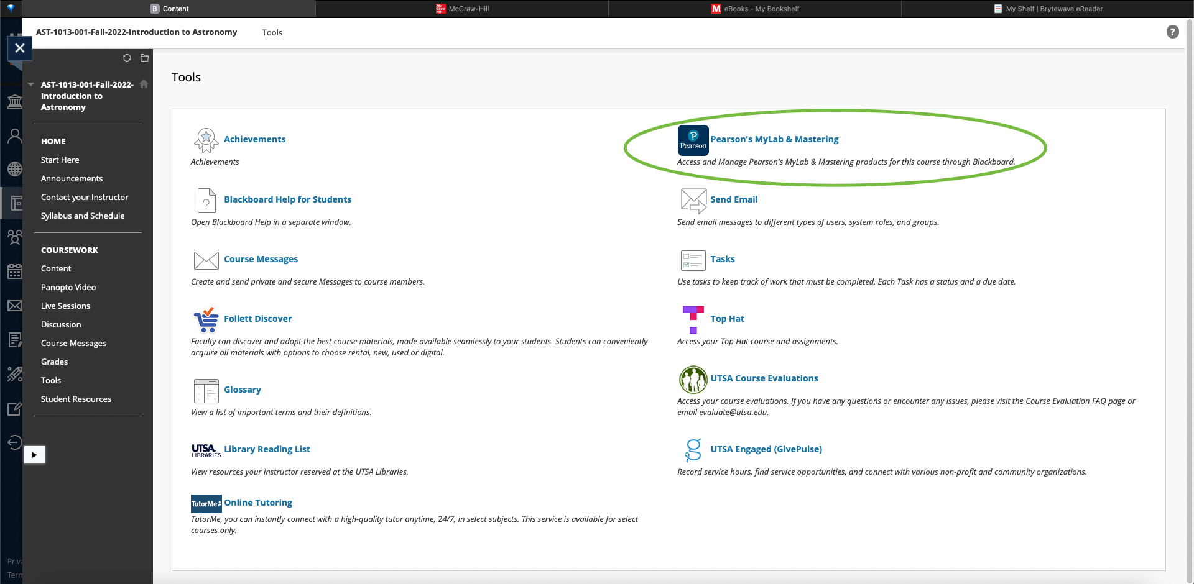
- Follow the instructions here:
https://help.pearsoncmg.com/integration/cg/student/content/get_started.htm
Blackboard Support can be found via UTSA Academic Innovation: Phone: 210-458-4520
If you contact Pearson Support, give them the course ID: anantua08974/

Activities and Grading
How course activities and grades will be assigned and evaluated:
Homework 45%
Take Home Quizzes 30%
Midterm Exam 15%
Participation 10%

Total 100%

Grade Distribution and Letter Grade
As shown, students will be able to demonstrate their learning during the semester in various ways, not only by examinations. Students’ work will be assessed and weighted according to the above scheme, noting that the lowest quiz and lowest homework grade is dropped in the calculation of one’s course grade. Late homework (submitted after Fri 2p) will not be accepted. Monitor one’s grade progress in real time using Blackboard. The numeric-to-letter grade conversion is shown below: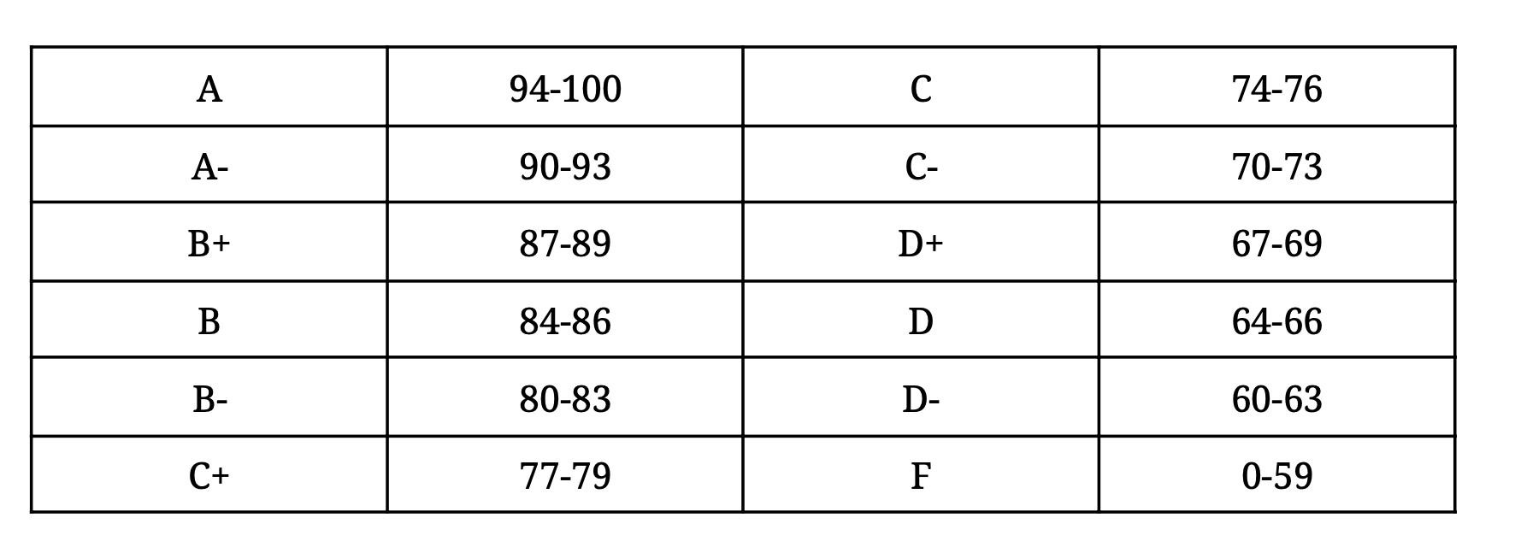

Essential Student Information
- Important: Bookmark and visit the Common Syllabus Information webpage to find important and valuable resources about counseling services, transitory/minor medical issues, supplemental instruction, tutoring services, academic success coaching, sexual harassment and sexual misconduct, campus safety and emergency preparedness, inclusivity statement, and the Roadrunner Creed.
- For technical requirements, support, and academic resources, visit the Student Support Gateway, where you can find all your tech and academic support resources in one place.
- Follow Online Learning Netiquette standards for your online communication activities. Please be mindful of the communication tools available in your course and use them for learning purposes. Class discussions take place in a respectful and safe environment, whether online or in person. UTSA encourages everyone to openly share their ideas and opinions without penalty or judgment, but learning should always be based on facts and research. It is possible to disagree without being disagreeable.
- UTSA provides reasonable accommodations to students via the Student Disability Services. For more details on eligibility, policies, and requirements, please visit www.utsa.edu/disability or call (210) 458-4157.
- UTSA Wellbeing Resources: your wellbeing is a priority for us. UTSA is proud to partner with Wellness 360 and MySSP to provide students with access to quality health and mental health care. Visit the UTSA Students Wellbeing Resources to explore the services available.

Instructor Contact Information
Instructor Name: Prof. Richard Anantua
Department and College: Department of Physics & Astronomy
Office Location: AET 3.386 or Zoom
Student hours: Wed 1:15p-2:15p via Zoom (email for appointment)
Phone Numbers: (210) 458-6564
Email Address: richard.anantua@utsa.edu

Communication Plan
The following is an example of a communication plan.
There are several ways you can communicate with me.
My preferred method of communication is:
- Email, you may email me at richard.anantua@utsa.edu. You may also use the Send Email tool in Blackboard.
- Course Messages tool in Blackboard, in case you need to send me a private message, for example, about a grade. This communication stays on Blackboard and is the only secure way to discuss your grade. You must log in to Blackboard to send and receive a course message.
- Post questions in the Course Q&A forum in Blackboard. This is a public forum provided for content and course-related questions. I encourage you to participate in this forum to get involved with your class.
Don’t hesitate to contact me and join the Student Support Hours

About Me
I am a new UTSA Assistant Professor excited to be part of your academic journey this semester. Intro to Astronomy is my first course here— and will thus be a learning experience for me and you.
My current research focuses on reverse engineering near-horizon supermassive black hole observations from intercontinental baselines of radio telescopes –primarily the Event Horizon Telescope (EHT)– using a methodology I call "Observing" Jet/Accretion flow/Black hole (JAB) Simulations. I lead the first EHT research group in Texas, primarily conducting research within the EHT Theory and Simulations Working Group. I also lead the EHT Outreach Group for the Americas, and have established nexuses between EHT and networks supporting diversity in the sciences such the NSBP/SAO EHT Scholars program.
My broad research interests have included: theoretical cosmology, high-energy theoretical astrophysics (e.g., Blandford-Znajek jets from supermassive black holes), high-energy theoretical particle physics (e.g., string theory [especially AdS/CFT correspondence]), condensed matter theory (e.g., strongly correlated fermionic systems with holographic dual).
My degrees are as follows:
Ph.D. in Physics; Stanford University 2016
Ed.M. in Education Policy and Management; Harvard University 2014
M.S. in Physics; Stanford University 2013
B.S. in Physics and Philosophy and B.S. in Economics and Mathematics; Yale University 2010

My Teaching Philosophy

My teaching philosophy can be found in this statement.

My Inclusivity Statement
The University of Texas at San Antonio, a Hispanic Serving Institution situated in a global city that has been a crossroads of peoples and cultures for centuries, values diversity and inclusion in all aspects of university life. As an institution expressly founded to advance the education of Mexican Americans and other underserved communities, our university is committed to ending generations of discrimination and inequity. UTSA, a premier public research university, fosters academic excellence through a community of dialogue, discovery, and innovation that embraces the uniqueness of each voice.
I have devoted much of my academic career to diversity and inclusion. Focusing on skills- and training-based initiatives as the key to leveling the educational playing field, I have started the NSBP/SAO EHT Scholars and UTSA-EHT Scholars and launch the next generation of diverse leaders. I look forward to championing and advocating for all my students.

Assessments and Assignments
Provide description of major assignments and assessments.
- Homework: We have a homework assignment or take home quiz assessment due Sun 11p each week starting Sun Sep 4, 2022 ending Sun Nov 20, 2022 to support student success.
- Quizzes: We will have regular take home quizzes complementing the homework. Research suggests early, frequent “low-stakes” assessment activities produce better outcomes. Refer to HOP Class Attendance and Policies for more details.
- Exams: This course will have an in-class Midterm Oct 4, 2022. There will be no final exam
- Participation: To support student success, this course will incorporate “active learning” assignments. Research shows that hands-on, applied, collaborative, problem-based, and context-relevant assignments engage students and produce better outcomes.

Course Schedule
For a list of important university-wide dates, review One Stop’s academic calendar. In particular, for Fall 2022, some key dates are:

Fall 2022 Key Dates
Nota bene: Weekly homework or quiz is due 11p (Central) on Sundays from Sept. 4 to Nov. 20. There will be three 4-week blocks of 3 homeworks followed by 1 quiz, with Quiz 1 due on 9/25, Quiz 2 due on 10/23 and Quiz 3 on 11/20.

Tu August 23 – First Day of Class 1:00p-2:15p

Su September 25 – Quiz 1 due 11p

Tu October 4 – Midterm Exam

Tu October 11 – Midterm Grades Due

Su October 23 – Quiz 2 due 11p

Th November 24 – Thanksgiving Holiday (No Class)

Su November 20 – Quiz 3 due 11p

Th December 1 – Last Day of Class

Tu December 13 – Final Course Grades Due on ASAP

Topic/Module List
The course will be subdivided into:
Unit 1: Astronomy Fundamentals – Chs. 1-5, 7
Unit 2: Stars – Chs. 8, 14, 16, 17, 18
Unit 3: Galaxies and Cosmology – Chs. 19-23

Course Management and Policies

Instructor-Initiated Drops
This course uses instructor-initiated drops for students who exceed the absence and/or missed assignment limit. Therefore, up to the last day for students to withdraw from an individual course, [10/24], you will be dropped for exceeding [10 absences or receiving and average of 50% or lower on assignments]. Students will receive at least one courtesy warning when approaching the absence/missed assignment limit. Notification will be sent via ASAP to the student’s email address. A subsequent absence or missed assignment will result in being dropped from the course. Notification of being dropped will also be sent via ASAP to the student’s email address. This drop does not affect enrollment in other courses. Please consult the Dropping Courses webpage for further details on the process and appeals.

Student Code of Conduct and Scholastic Dishonesty
The Student Code of Conduct is Section B of the Appendices in the Student Information Bulletin. Scholastic Dishonesty is listed in the Student Code of Conduct (Sec. B of the Appendices) under Sec. 203.

Copyright and Fair Use
It is important to understand the issue of intellectual property rights. You may not use the images or thoughts of others for profit or gain without their written permission. The UTSA library has a Copyright Laws and Public Performance Rights (PPR) page.

Students with Disabilities
The University of Texas at San Antonio, in compliance with the Americans with Disabilities Act and Section 504 of the Rehabilitation Act, provides “reasonable accommodations” to students with disabilities. Only those students who have officially registered with Student Disability Services and requested accommodations for this course will be eligible for disability accommodations. Instructors at UTSA must be provided official notification of accommodation through Student Disability Services. Information regarding diagnostic criteria and policies for obtaining disability-based academic accommodations can be found at www.utsa.edu/disability or by calling Student Disability Services at (210) 458-4157. Accommodations are not retroactive.

Family Educational Rights and Privacy Act (FERPA)
FERPA grants students the right to control certain disclosures of their educational records. For a full explanation of your rights and to grant access to FERPA educational records, go to Student Catalog Annual FERPA Letter and One Stop Enrollment – FERPA Proxy Access. Without your consent or authorization of proxy access, UTSA may release Directory Information, such as but not limited to your name, email, phone, place of birth, and photograph, unless you have opted out of the release of Directory Information. To opt out, go to Restrict Directory Information Form. Mandatory Reporting of Sexual Misconduct and Reporting of Health and Safety Information: If a student discloses an incident of sexual misconduct to any UTSA employee (other than to a designated confidential employee such as mental health counselor or PEACE advocate, a UTSA police officer using a pseudonym form or at a public awareness event), that information is not confidential, and the UTSA employee must report all known information to the UTSA Office of Equal Opportunity Services. Employees may also report any concerns about the health and safety of students or others to other school officials and/or law enforcement. For a complete list of exceptions to FERPA, please see Student Catalog Annual FERPA Letter and HOP 5.01.

Video and audio recording
As the instructor of this course, I may record meetings and lessons. You are expected to follow appropriate University policies and maintain the security of passwords used to access recorded lectures. Recordings may not be published, reproduced, or shared with those not in the class. If the instructor or a UTSA office plans any other uses for the recordings, consent of the students identifiable in the recordings is required before such use unless an exception is allowed by law. For more information on your privacy and class recordings, review Student Privacy (FERPA) in Virtual Classrooms and Other Educational Recordings and the Guide to Secure Video Conferencing Tools.

Note: The syllabus is subject to change at the instructor’s discretion. Any changes/corrections to the course materials, assignment dates, or other updates will be communicated to the students ahead of time. You are responsible for checking Blackboard for corrections or updates to the syllabus.

